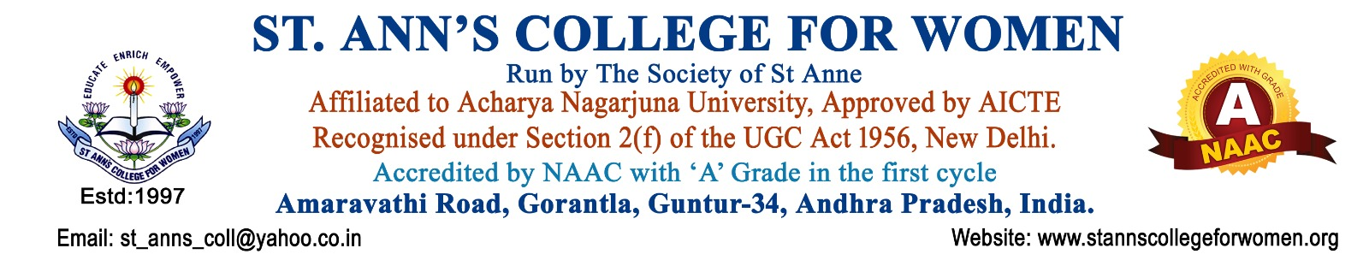

NCC Unit
1. Introduction
The NCC Unit of St. Ann’s College for Women, Gorantla, Guntur is established to promote discipline, leadership, patriotism, character building, national integration, and social responsibility among students through the activities of the National Cadet Corps (NCC).
The NCC Unit functions in accordance with the guidelines of the National Cadet Corps, UGC, and NAAC to provide students with opportunities for personality development, community service, adventure activities, and leadership training. The unit aims to develop responsible citizens committed to national service and social welfare.
2. Vision
To develop disciplined, confident, patriotic, and socially responsible young women through NCC training and service activities.
3. Mission
- To motivate students to participate actively in NCC activities.
- To inculcate leadership qualities, discipline, and national spirit.
- To promote community service, social awareness, and environmental responsibility.
- To prepare students for responsible citizenship and career opportunities in defense and public services.
4. Objectives
The objectives of the NCC Unit are to:
- Promote the aims, objectives, and activities of the National Cadet Corps.
- Encourage student enrollment and participation in NCC.
- Develop discipline, leadership, self-confidence, and patriotism among cadets.
- Organize regular NCC drills, parades, and training sessions.
- Coordinate participation in NCC camps and national-level programs.
- Promote community service and social responsibility.
- Conduct awareness programs on national integration, health, hygiene, and environmental protection.
- Encourage participation in cleanliness drives, blood donation camps, and outreach activities.
- Foster team spirit, physical fitness, and leadership qualities among cadets.
- Maintain records of cadets, attendance, achievements, and activities.
5. Scope of Activities
The NCC Unit shall organize and participate in activities related to:
- NCC drills and parades
- Leadership and personality development
- National integration programs
- Community service activities
- Cleanliness and environmental drives
- Blood donation awareness programs
- Health and hygiene campaigns
- Adventure and camp activities
- Republic Day and Independence Day celebrations
- Disaster management and social awareness programs

